# 安装包下载

## CDH

<https://archive.cloudera.com/cm6/6.3.1/redhat7/yum/>

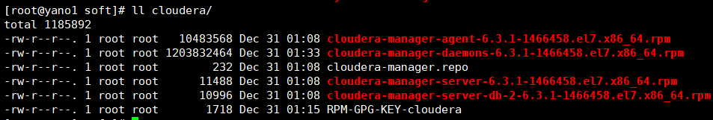

<https://archive.cloudera.com/cdh6/6.3.1/parcels/>

## Python 2.7

<https://www.python.org/downloads/release/python-278/>

## JDK 8

<https://www.oracle.com/technetwork/java/javase/downloads/jdk8-downloads-2133151.html>



## Mysql 5.7

[https://cdn.mysql.com//Downloads/MySQL-5.7/mysql-5.7.26-1.el7.x86_64.rpm-bundle.tar](https://cdn.mysql.com/Downloads/MySQL-5.7/mysql-5.7.26-1.el7.x86_64.rpm-bundle.tar)

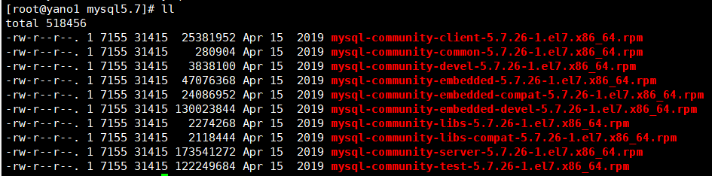

<http://central.maven.org/maven2/mysql/mysql-connector-java/8.0.16/mysql-connector-java-8.0.16.jar>



# 基础环境准备

## 修改主机名

每个主机执行命令设置主机名称

hostnamectl set-hostname yano1

## 修改HOST

每个主机编辑hosts文件，加入集群主机的信息

vi /etc/hosts

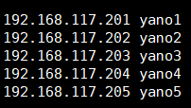

## 关闭防火墙

systemctl disable firewalld

systemctl stop firewalld

## 同步主机时间

yum install ntp –y

ntpdate ntp1.aliyun.com

sed -i 's/server 0.centos.pool.ntp.org iburst/server ntp1.aliyun.com/g' /etc/ntp.conf

sed -i 's/server 1.centos.pool.ntp.org iburst/server ntp2.aliyun.com/g' /etc/ntp.conf

sed -i 's/server 2.centos.pool.ntp.org iburst/server ntp3.aliyun.com/g' /etc/ntp.conf

sed -i 's/server 3.centos.pool.ntp.org iburst/server ntp4.aliyun.com/g' /etc/ntp.conf

systemctl enable ntpd

systemctl start ntpd

## 配置主机免密

在所有主机上执行: ssh-keygen -t rsa ,一路回车,生产自己的秘钥

在所有主机上执行: cat /root/.ssh/id_rsa.pub >> /root/.ssh/authorized_keys

汇集ssh秘钥 ssh-copy-id -i yano1

分发至其他主机

scp /root/.ssh/authorized_keys yano2:/root/.ssh/

scp /root/.ssh/authorized_keys yano3:/root/.ssh/

scp /root/.ssh/authorized_keys yano4:/root/.ssh/

scp /root/.ssh/authorized_keys yano5:/root/.ssh/

## 修改虚拟内存交换页大小

sysctl -w vm.swappiness=0

echo "vm.swappiness=0" > /etc/sysctl.conf

## 禁用透明页

echo never > /sys/kernel/mm/transparent_hugepage/defrag

echo never > /sys/kernel/mm/transparent_hugepage/enabled

echo "echo never > /sys/kernel/mm/transparent_hugepage/enabled" >>  /etc/rc.local

echo "echo never > /sys/kernel/mm/transparent_hugepage/defrag" >>  /etc/rc.local

chmod u+x /etc/rc.local

## 其他依赖

yum install -y bind-utils psmisc libxslt cyrus-sasl-plain cyrus-sasl-gssapi fuse portmap fuse-libs httpd mod_ssl python-psycopg2 MySQL-python redhat-lsb

# 运行环境准备

## 安装JDK

rpm -ivh jdk-8u221-linux-x64.rpm

## 安装Python

安装依赖：

yum install -y readline-devel sqlite-devel bzip2-devel openssl-devel gdbm-devel libdbi-devel ncurses-libs zlib-devel expat-devel libffi-devel openssl

解压Python包

tar -zxvf Python-2.7.8

cd Python-2.7.8

./configure

make && make install

## 拷贝JDBC驱动

mkdir /usr/share/java

cp mysql-connector-java-8.0.16.jar /usr/share/java/

mv /usr/share/java/mysql-connector-java-8.0.16.jar /usr/share/java/mysql-connector-java.jar

## 安装MySQL

卸载所以mysql和mariadb

rpm -qa | grep mysql

rpm -e --nodeps mysql...

rpm -qa | grep mariadb

rpm -e --nodeps mariadb...

解压安装包

tar -xvf mysql-5.7.26-1.el7.x86_64.tar

安装MySQL

yum install mysql-community-server-5.7.26-1.el7.x86_64.rpm mysql-community-common-5.7.26-1.el7.x86_64.rpm mysql-community-libs-5.7.26-1.el7.x86_64.rpm mysql-community-client-5.7.26-1.el7.x86_64.rpm –y

启动mysql

systemctl start mysqld

systemctl enable mysqld

获取临时密码

grep 'temporary password' /var/log/mysqld.log

登录MySQL

mysql -uroot –p

修改密码

GRANT ALL PRIVILEGES ON *.* TO 'root'@'%' IDENTIFIED BY 'yyalx' WITH GRANT OPTION;

编辑配置文件

vi /etc/my.cnf

lower_case_table_names=1 #配置表名不区分大小写

character-set-server=utf8 #设置为默认编码为utf8

init_connect='SET NAMES utf8'

max_connections=1024 #设置最大连接数

并按实际情况调整datadir数据目录

重启MySQL生效配置

systemctl restart mysqld

重新登录MySQL创建数据库

mysql> CREATE DATABASE scm DEFAULT CHARACTER SET utf8 DEFAULT COLLATE utf8_general_ci;

mysql> CREATE DATABASE hive DEFAULT CHARACTER SET utf8 DEFAULT COLLATE utf8_general_ci;

mysql> CREATE DATABASE rmon DEFAULT CHARACTER SET utf8 DEFAULT COLLATE utf8_general_ci;

mysql> CREATE DATABASE oozie DEFAULT CHARACTER SET utf8 DEFAULT COLLATE utf8_general_ci;

mysql> CREATE DATABASE hue DEFAULT CHARACTER SET utf8 DEFAULT COLLATE utf8_general_ci;

# 安装Cloudera Manager

## 安装Cloudera Manager Server

在Server机器节点安装MySQL-libs

rpm -ivh mysql-community-common-5.7.26-1.el7.x86_64.rpm

rpm -ivh mysql-community-libs-5.7.26-1.el7.x86_64.rpm

rpm -ivh mysql-community-libs-compat-5.7.26-1.el7.x86_64.rpm

安装daemons

rpm -ivh cloudera-manager-daemons-6.3.1-1466458.el7.x86_64.rpm

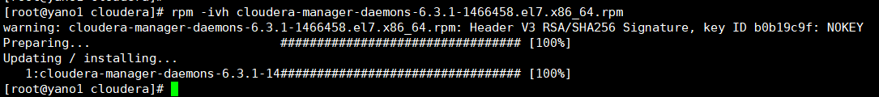

安装agent

rpm -ivh cloudera-manager-agent-6.3.1-1466458.el7.x86_64.rpm

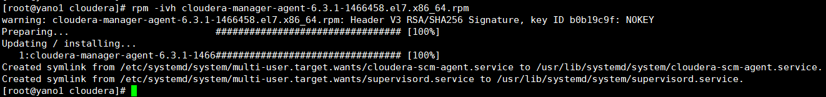

安装server

rpm -ivh cloudera-manager-server-6.3.1-1466458.el7.x86_64.rpm

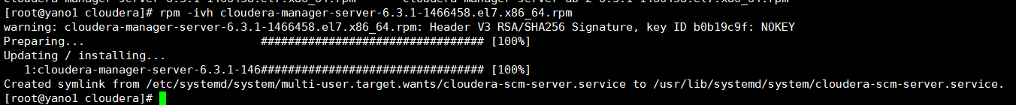

初始化数据库（使用上述MySQL数据库信息）

cd /opt/cloudera/cm/schema/

./scm_prepare_database.sh -h yano1 -P 3306 mysql scm root yyalx

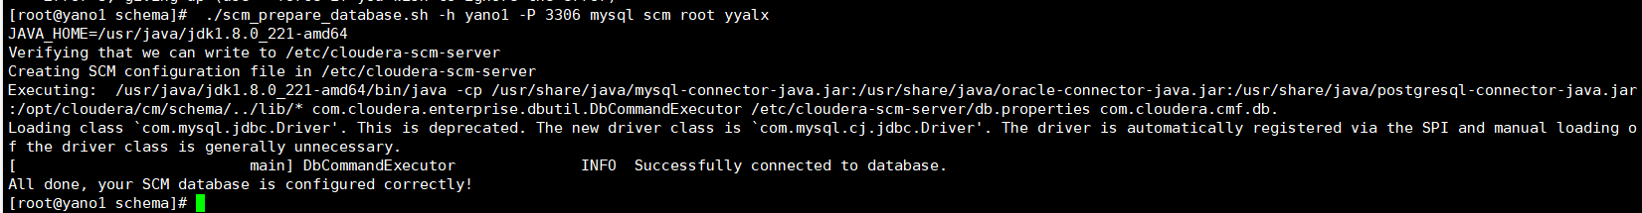

## 安装Cloudera Manager Agent

在Agent机器节点安装MySQL-libs

rpm -ivh mysql-community-common-5.7.26-1.el7.x86_64.rpm

rpm -ivh mysql-community-libs-5.7.26-1.el7.x86_64.rpm

rpm -ivh mysql-community-libs-compat-5.7.26-1.el7.x86_64.rpm

安装daemons

rpm -ivh cloudera-manager-daemons-6.3.1-1466458.el7.x86_64.rpm

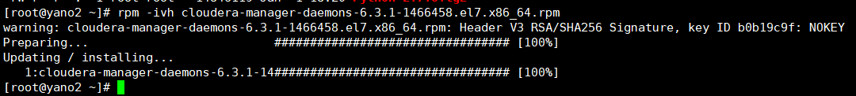

安装agent

rpm -ivh cloudera-manager-agent-6.3.1-1466458.el7.x86_64.rpm



编辑agent配置文件

vim /etc/cloudera-scm-agent/config.ini

修改server_host

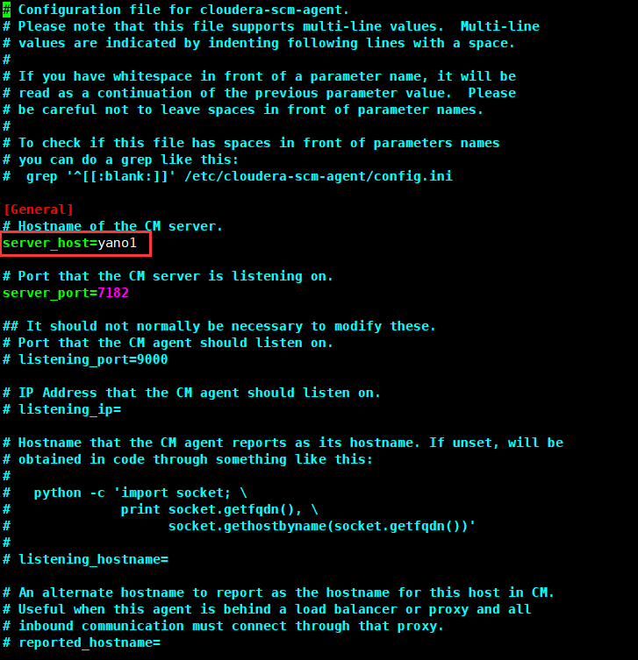

## 移动parcel文件

移动三个文件至/opt/cloudera/parcel-repo/文件夹

mv CDH-6.3.1-1.cdh6.3.1.p0.1470567-el7.parcel /opt/cloudera/parcel-repo/

mv CDH-6.3.1-1.cdh6.3.1.p0.1470567-el7.parcel.sha1 /opt/cloudera/parcel-repo/CDH-6.3.1-1.cdh6.3.1.p0.1470567-el7.parcel.sha

mv manifest.json /opt/cloudera/parcel-repo/

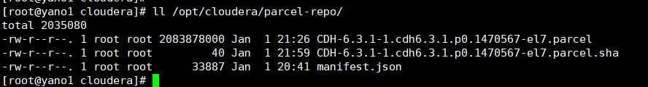

## 启动Cloudera Manager

在Server机器节点执行

systemctl start cloudera-scm-server

systemctl enable cloudera-scm-server

systemctl start cloudera-scm-agent

systemctl enable cloudera-scm-agent

启动日志

tail -f /var/log/cloudera-scm-server/cloudera-scm-server.log

在Agent机器节点执行

systemctl start cloudera-scm-agent

systemctl enable cloudera-scm-agent

tail -f /var/log/cloudera-scm-agent/cloudera-scm-agent.log

server启动完毕后

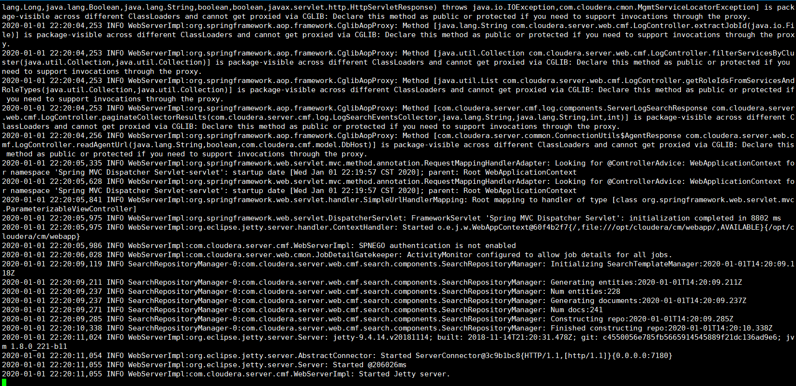

可以打开页面ip:7180

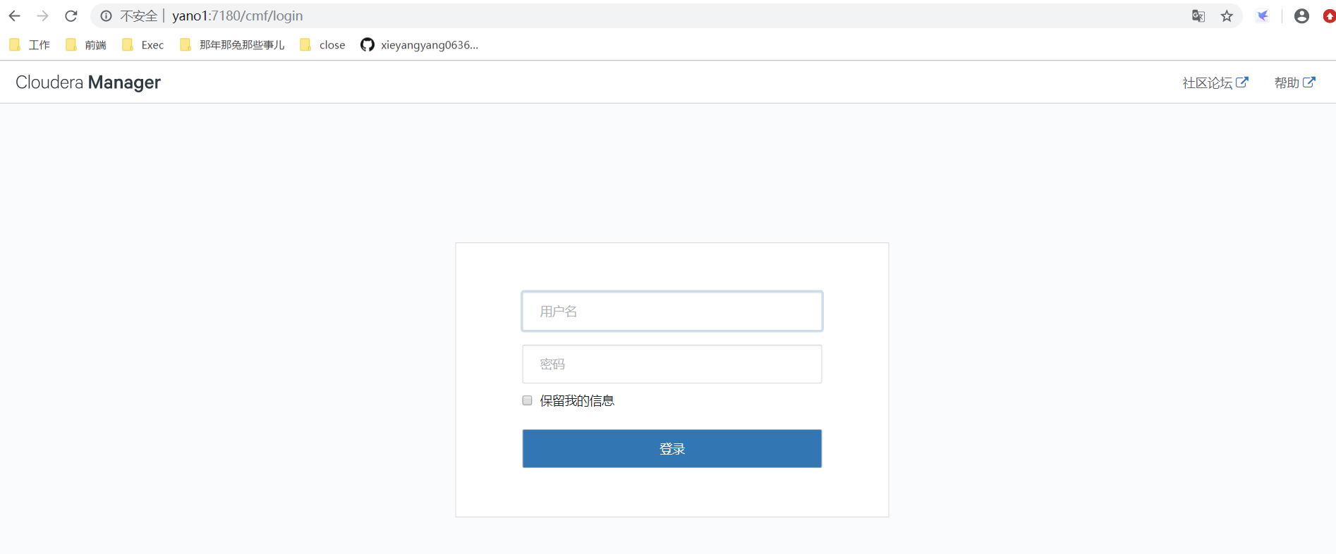

默认用户名密码为 admin/admin

## 安装集群

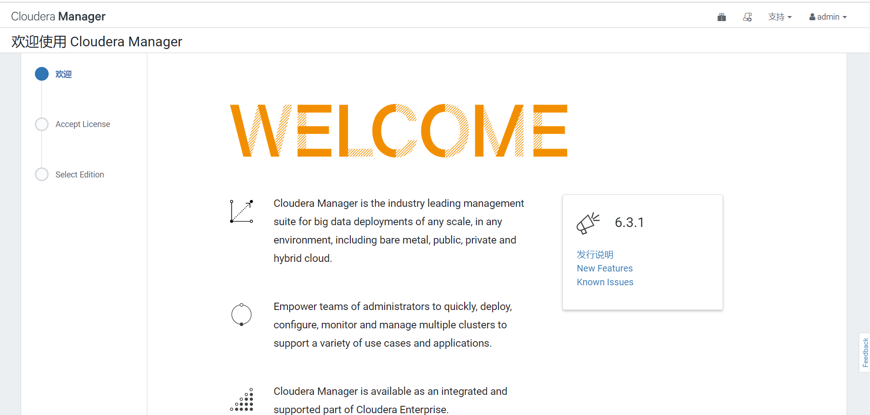

选择【继续】

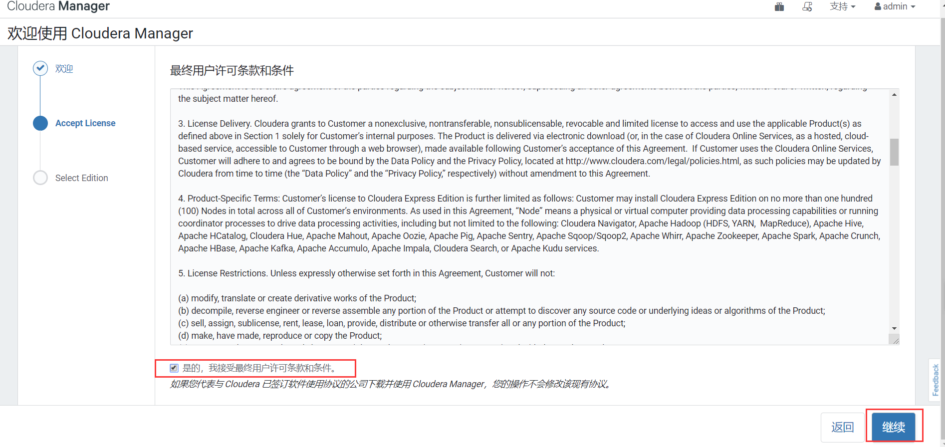

选择合适的版本选择继续

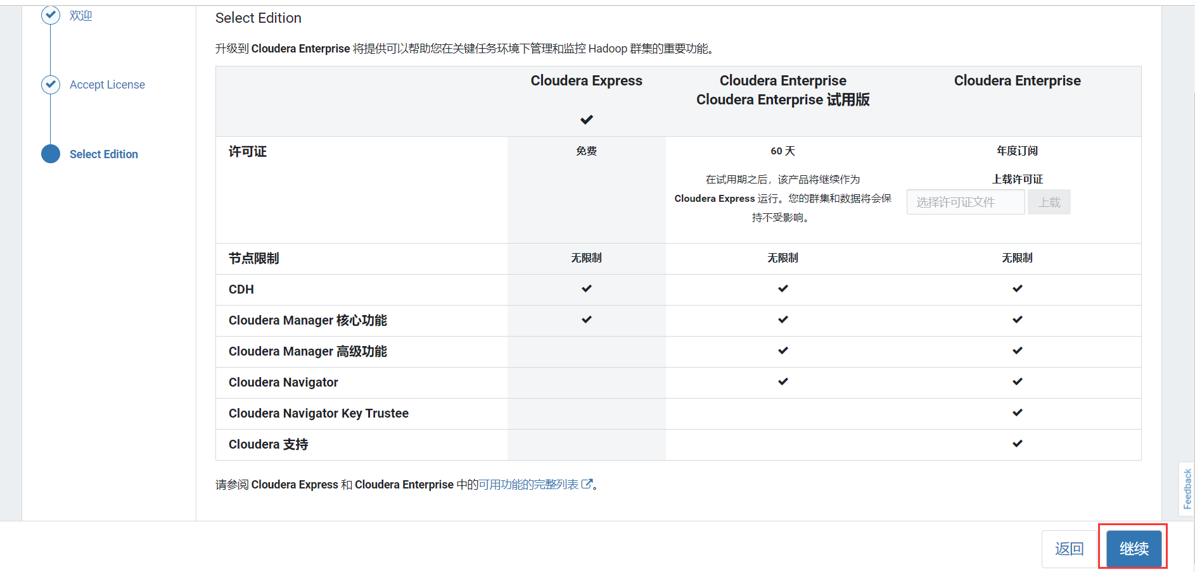

来到集群安装界面

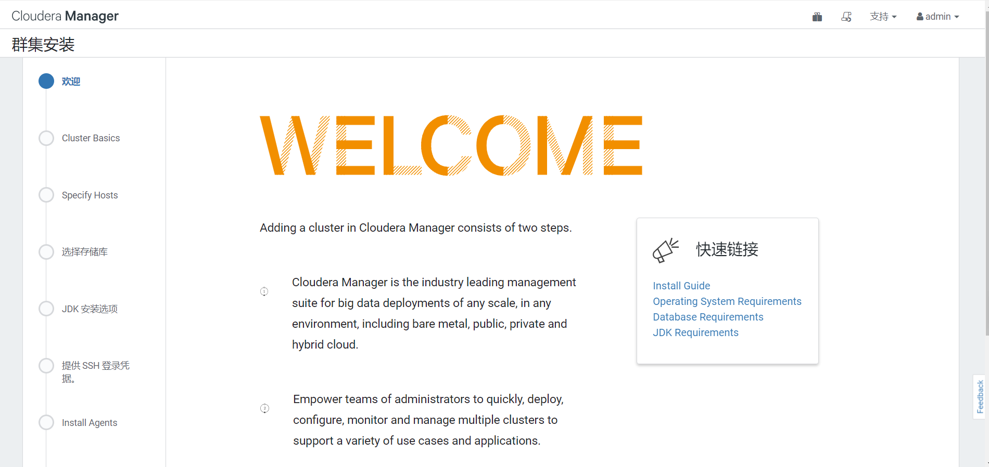

填写集群名称后继续

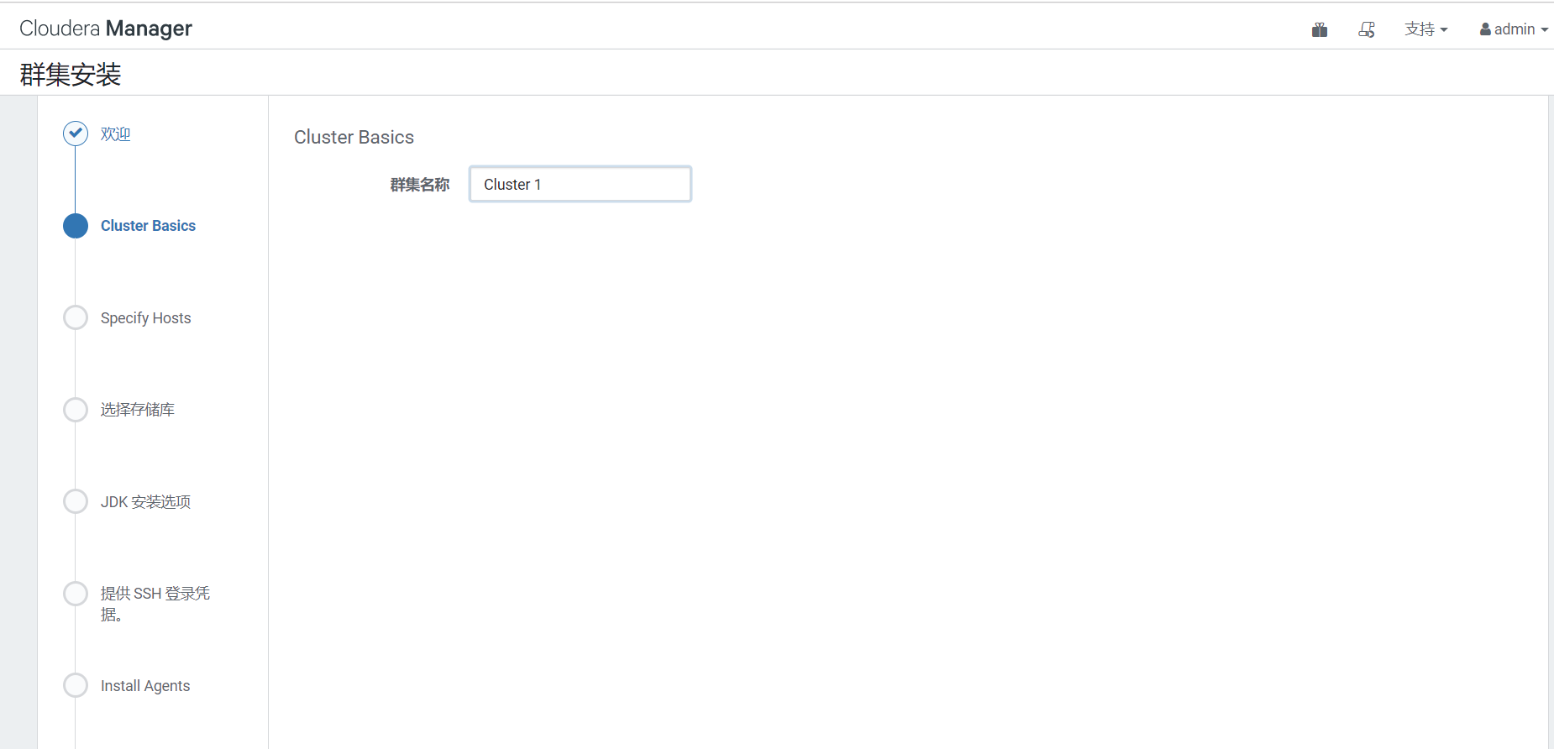

选择主机选择继续

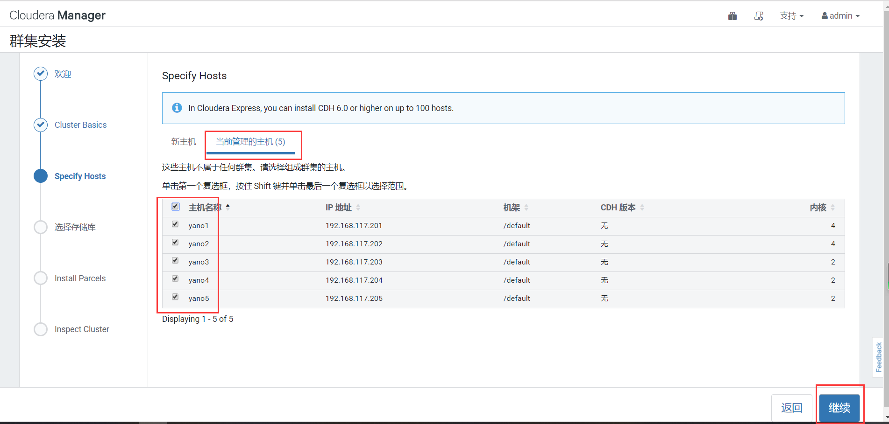

选择准备好的parcel包 后继续

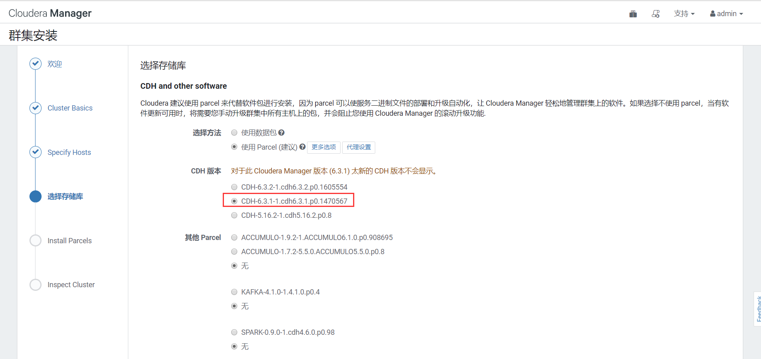

等待Install Parcels执行完成

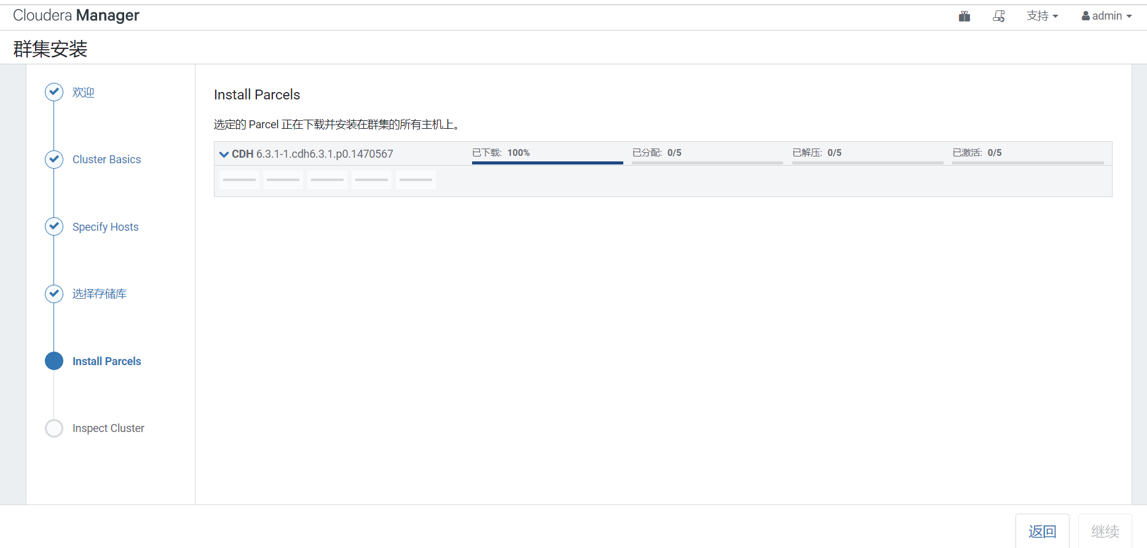

根据实际选择

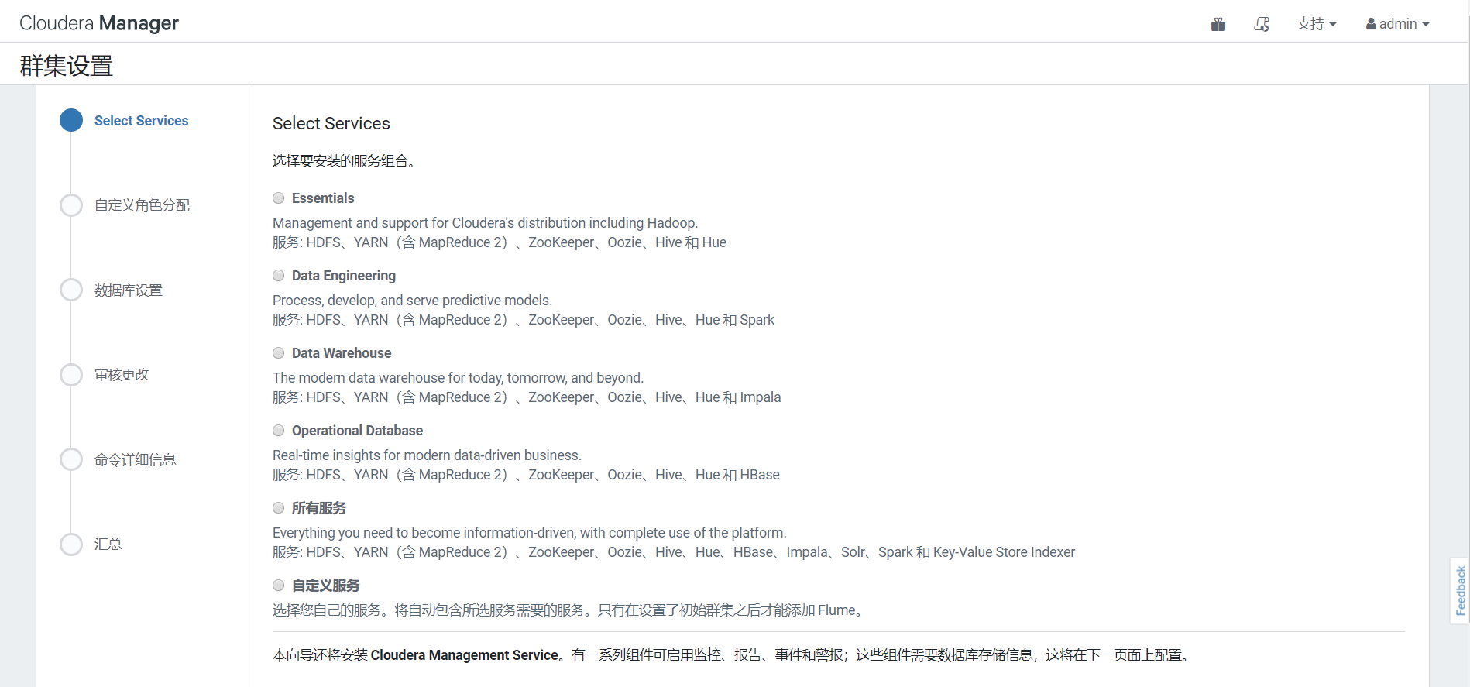

这里以自定义举例

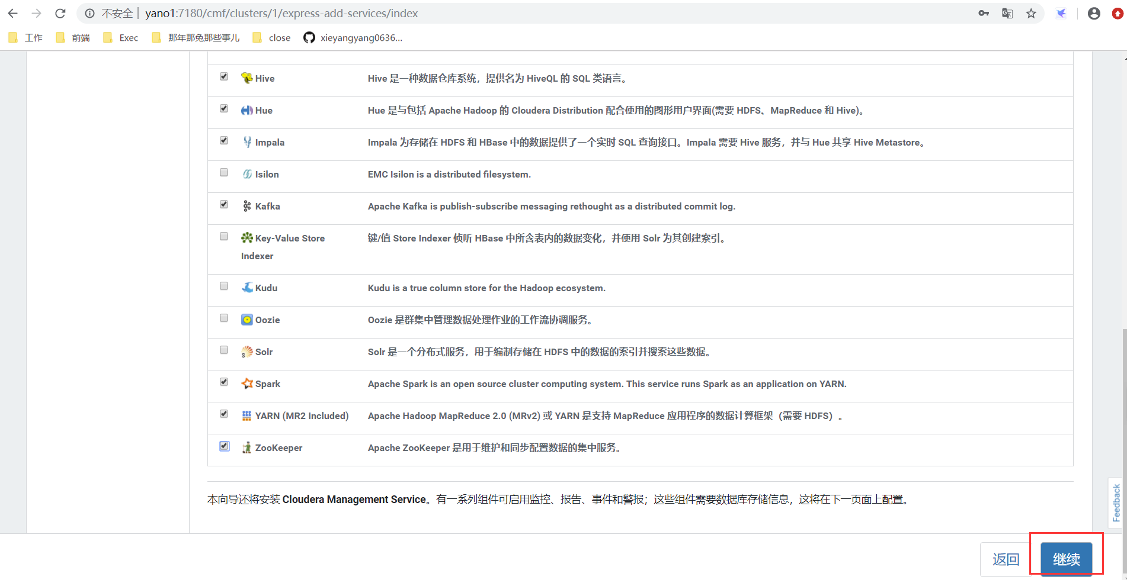

分配好角色选择继续

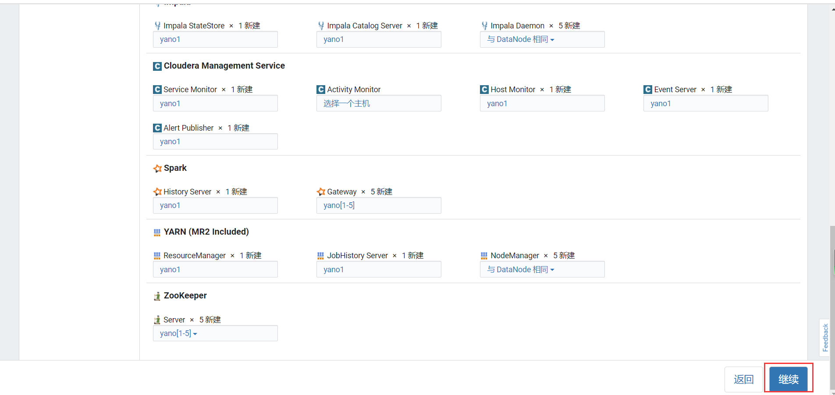

配置好MySQL数据库，选择继续

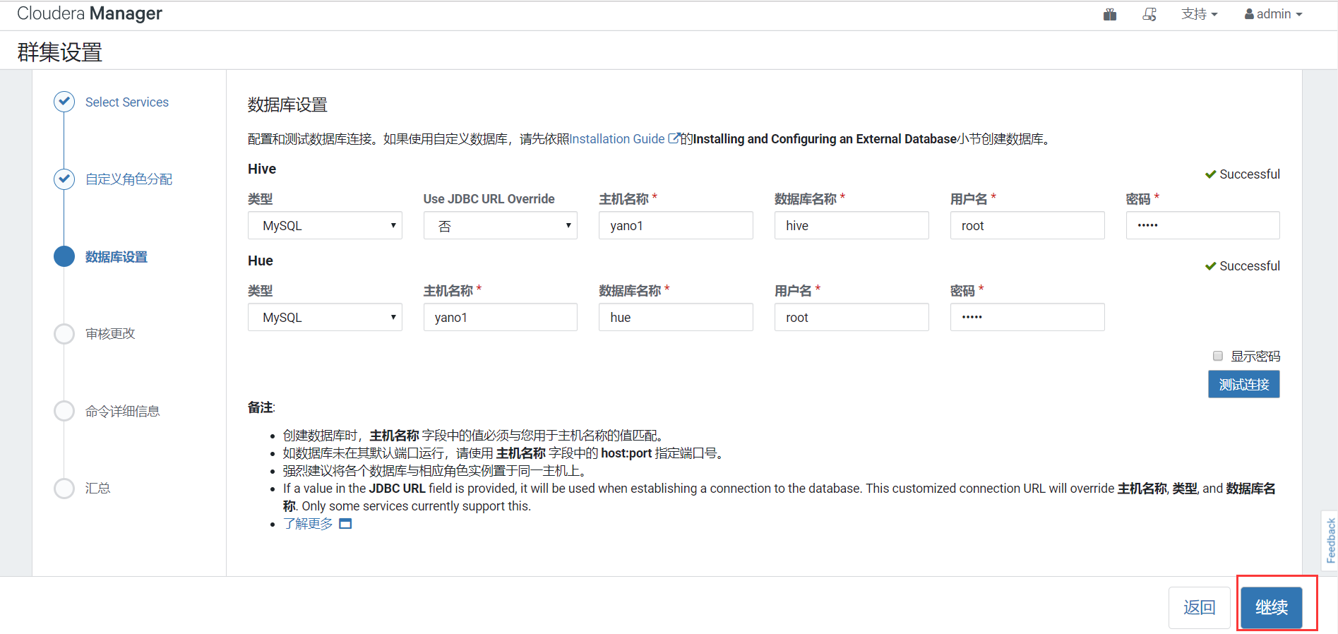

审核更改没问题后等待执行完成

